Introduction:

Reference 1: Fourier transform based LSTM stock prediction model under oil shocks

This paper analysed the impact of oil shocks on stock price using an LSTM and fourier analysis—the paper used per-day stock price data of S&P50 stock index and WTI oil futures contract.

Five oil shock measurements were taken as inputs:

1. Net price increase
2. Asymmetric net price change
3. Symmetric net price change
4. Large price increase
5. Net price increase indicator

The paper took RVt as a measure of volatility

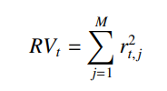

M is the index of samples in month t, rt, j acts as the jth daily return of month t.

The paper calculated RVt and plotted it over time. It was observed that there is a certain frequency where the changes are happening. Then it applied fourier analysis to find the frequency at which these changes are happening. Then the data at those particular time period are taken for consideration. Then the data is fed into the LSTM

LSTM architecture:

* 3 layer structure
* 1st layer - 512 neurons
* 2nd layer - 128 neurons with sigmoid
* 3rd layer - 128 neurons
* 1500 epochs

As the paper trained a Fourier transform based LSTM model and evaluated results using different stock price data. The results showed varied trends in different stock prices correlated in various ways with oil prices. The usage of Fourier analysis based LSTM showed to e roust enough in predicting the price trends. Additional analysis and evaluation were done to reassure the robustness of the model.

Reference 2:

The impact of stock market price Fourier transform analysis on the Gated Recurrent Unit classifier model. It studies the trends in signals from different sources. It selects few parameters like open price, closing price, lowest price, highest price of stocks then applies fourier transform to extract new features. Then it extracts the results and compares the results with selected benchmark.

The paper uses the Limit order book(LOB) data obtained from the LOBSTER dataset. A LOB is a place where all the details related to all the limit orders are stored. It contains two sides. One is Bid side where all the Buy orders are stored. Another is ask side where all the sell orders are placed. The image shows how LOB looks.

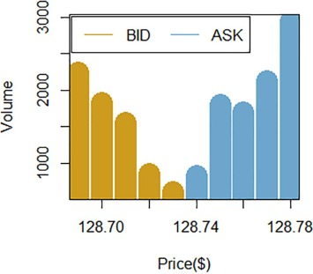

As part of data cleaning, cancelled orders are removed and as part of preprocessing, the details from the message book is appended for the data to look like below.

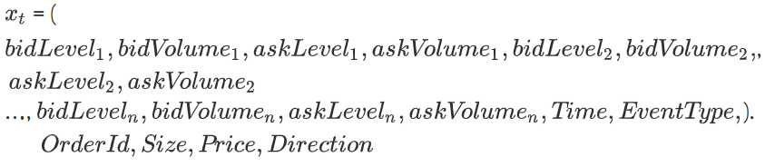

In the data preprocessing section, technical indicators are applied to further process data.

A GRU is taken for consideration. Two sets of inputs are taken. One is the data containing LOB and technical indicators. Another is the data containing LOB and technical indicators and features that employ Fourier analysis. Then the model is trained using these two sets separately. The SUS algorithm is used for feature extraction while training.

After testing, the following results are observed. These results clearly show the model performed well with fourier transform features are present in the inut set.

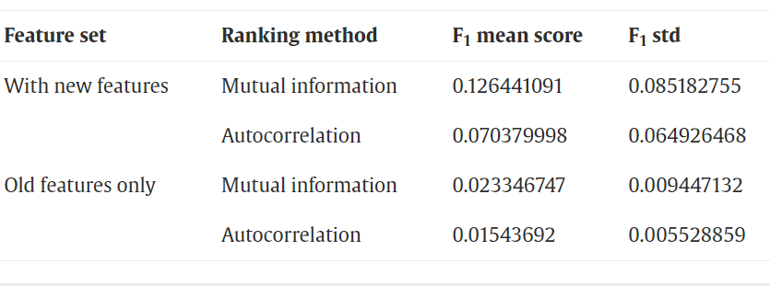

Methods:

Yahoo Finance, Nasdaq 100 Mar 23, accessed 07 March 2023, <https://finance.yahoo.com/quote/NQ%3DF/history?p=NQ%3DF>

Github link:

Appendices:

Q1) how robust is fourier analysis while predicting stock prices?

ChatGPT answer: [Retrieved 3/7/2023]

Fourier analysis is a mathematical tool that decomposes a complex signal, such as a time series of stock prices, into simpler periodic components. While Fourier analysis can be useful for identifying patterns in stock price data, it is not a reliable method for predicting stock prices.

Stock prices are highly complex and unpredictable, affected by a variety of factors including economic indicators, company performance, and global events. Fourier analysis alone is not sufficient to capture all of the factors that drive stock price movements. Moreover, past performance does not necessarily indicate future performance, so even if Fourier analysis accurately identifies patterns in historical data, these patterns may not continue in the future.

To predict stock prices with reasonable accuracy, analysts typically use a combination of approaches, including fundamental analysis, technical analysis, and machine learning algorithms. These methods take into account a wide range of factors, including company financials, industry trends, and sentiment analysis of news and social media.

In summary, while Fourier analysis can be useful for identifying patterns in stock price data, it should not be relied upon as the sole method for predicting stock prices. A more comprehensive approach, such as a combination of fundamental and technical analysis, may provide more reliable results.

Q2) how can I use Machine learning along with fourier analysis to effectively predict stock prices

ChatGPT answer: [Retrieved 3/7/2023]

Machine learning algorithms can be used in conjunction with Fourier analysis to make more accurate predictions about stock prices. Here are some steps you can take to use machine learning algorithms along with Fourier analysis to predict stock prices effectively:

1. Collect and preprocess data: Gather historical stock price data and any relevant economic and financial indicators that may impact the stock price. Preprocess the data by removing any outliers or missing values, and scale the data so that each feature has a similar range.
2. Apply Fourier analysis: Use Fourier analysis to decompose the stock price data into simpler periodic components. This will help identify patterns in the data and extract features that can be used for machine learning.
3. Feature engineering: Use the periodic components extracted from Fourier analysis as input features to the machine learning model. Additionally, engineer other relevant features, such as economic indicators or news sentiment scores, to improve the predictive power of the model.
4. Train the machine learning model: Split the data into training and testing sets, and train the machine learning model using the training set. Use a variety of regression algorithms, such as linear regression, decision tree regression, or neural network regression, to train the model and select the best performing algorithm based on the testing set.
5. Evaluate the model: Evaluate the performance of the machine learning model using metrics such as mean squared error (MSE), mean absolute error (MAE), and root mean squared error (RMSE). Adjust the hyperparameters of the model, such as the number of Fourier components or the learning rate of the neural network, to optimize the performance of the model.
6. Make predictions: Use the trained machine learning model to make predictions about future stock prices. Monitor the performance of the model over time and adjust the model as necessary to ensure continued accuracy.

In summary, using machine learning algorithms along with Fourier analysis can help improve the accuracy of stock price predictions. By combining these approaches, analysts can identify patterns in historical data and use them to make more accurate predictions about future stock price movements.